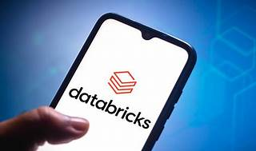

Explore

**Databricks** is a **cloud-based platform** that manages and analyzes large datasets using the **Apache Spark** open-source big data processing engine. [It provides a unified workspace for data scientists, engineers, and business analysts to collaborate, develop, and deploy data-driven applications, integrating with cloud storage and security1](https://docs.databricks.com/en/introduction/index.html).

Here are **five free learning resources** to explore Databricks:

1. [**Databricks on AWS Documentation**](https://docs.databricks.com/en/introduction/index.html): Learn about Databricks, its architecture, and common use cases[1](https://docs.databricks.com/en/introduction/index.html).
2. [**Databricks - Wikipedia**](https://en.wikipedia.org/wiki/Databricks): Explore details about Databricks, including its origins and features[2](https://en.wikipedia.org/wiki/Databricks).
3. [**What is Databricks: A 101 Guide for Beginners**](https://hevodata.com/learn/what-is-databricks/): A beginner-friendly guide covering Databricks basics and use cases[3](https://hevodata.com/learn/what-is-databricks/).
4. [**Databricks Academy**](https://www.databricks.com/learn/training/home): Access hands-on tutorials, certification, and training for mastering Databricks[4](https://www.databricks.com/learn/training/home).
5. [**Get Started Resources**](https://community.databricks.com/t5/get-started-resources/ct-p/GetStartedResources): Daily onboarding training, guides, and notebooks to fast-track your understanding of Databricks[5](https://community.databricks.com/t5/get-started-resources/ct-p/GetStartedResources).

Happy learning! 🚀